**Predicting the area best for opening restaurant**

Sushant

March 06,2020

1. **Introduction**
   1. *Background*

Restaurant is a [business](https://en.wikipedia.org/wiki/Business) that prepares and serves [food](https://en.wikipedia.org/wiki/Food) and [drinks](https://en.wikipedia.org/wiki/Drink) to [customers](https://en.wikipedia.org/wiki/Customer). Meals are generally served and eaten on the [premises](https://en.wikipedia.org/wiki/Premises), but many restaurants also offer [take-out](https://en.wikipedia.org/wiki/Take-out) and [food delivery services](https://en.wikipedia.org/wiki/Delivery_(commerce)). Restaurants vary greatly in appearance and offerings, including a wide variety of [cuisines](https://en.wikipedia.org/wiki/Cuisine) and [service](https://en.wikipedia.org/wiki/Customer_service) models ranging from inexpensive [fast food restaurants](https://en.wikipedia.org/wiki/Fast_food_restaurant) and [cafeterias](https://en.wikipedia.org/wiki/Cafeteria), to mid-priced [family restaurants](https://en.wikipedia.org/wiki/Family_restaurant), to high-priced luxury establishments.

In Western countries, most mid- to high-range restaurants serve [alcoholic beverages](https://en.wikipedia.org/wiki/Alcoholic_beverage) such as [beer](https://en.wikipedia.org/wiki/Beer) and [wine](https://en.wikipedia.org/wiki/Wine). Some restaurants serve all the major meals, such as [breakfast](https://en.wikipedia.org/wiki/Breakfast), [lunch](https://en.wikipedia.org/wiki/Lunch), and [dinner](https://en.wikipedia.org/wiki/Dinner) (e.g., major fast food chains, diners, hotel restaurants, and airport restaurants). Other restaurants may serve only a single meal (for example, a [pancake house](https://en.wikipedia.org/wiki/Pancake_house) may only serve breakfast) or they may serve two meals (e.g., lunch and dinner).

* 1. *Problem*

Determining the best place for opening different type of restaurant in Toronto on the basis of their menu and services. The project aims to suggest the area’s for opening different type of restaurant such that the owner get maximum profit or get maximum customer .

**2. Data acquisition and cleaning**

2.1 *Data sources*

I get data for neighbourhood location in Toronto from Wiki and also using geographical coordinates of the neighbourhoods from <https://cocl.us/Geospatial_data> , From Foursquare API I get names, category, latitude, longitude of different location .

2.1 *Data cleaning*

Data downloaded or scraped from multiple sources were combined into one table. There were a lot of missing values because of the lack of record-keeping. I decided to fill data according to different

Parameter and after applying all stuff to fill data if there is any other data are missing then I drop the data and also drop the dependent data if it is missing.

After that, I extract **Feature Data** for the data set. feature data are those data which is responsible for suggesting a different location for the opening restaurant it is consist of name Borough, latitude, longitude, Postal-code, neighbourhood.

**3. Exploratory Data Analysis**

*3.1 Calculation of target variable*

Aim to find the existing restaurant at different places in Toronto by using foursquare API which checks nearby venues in approx. the radius of 200km and return the data of all the venues nearby, After that, I decided to extract useful information from it such as a normal restaurant and append it into our existing data frame for calculation.

*3.2 Data Visualisation*

Now I see the relationship between the different factor and different plots are:-

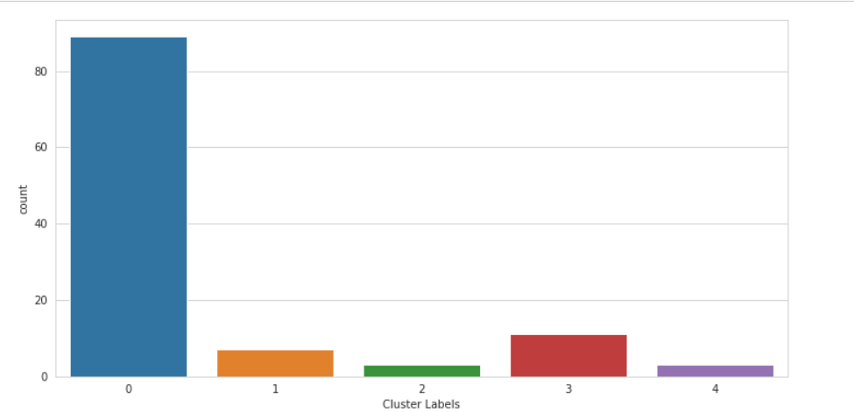

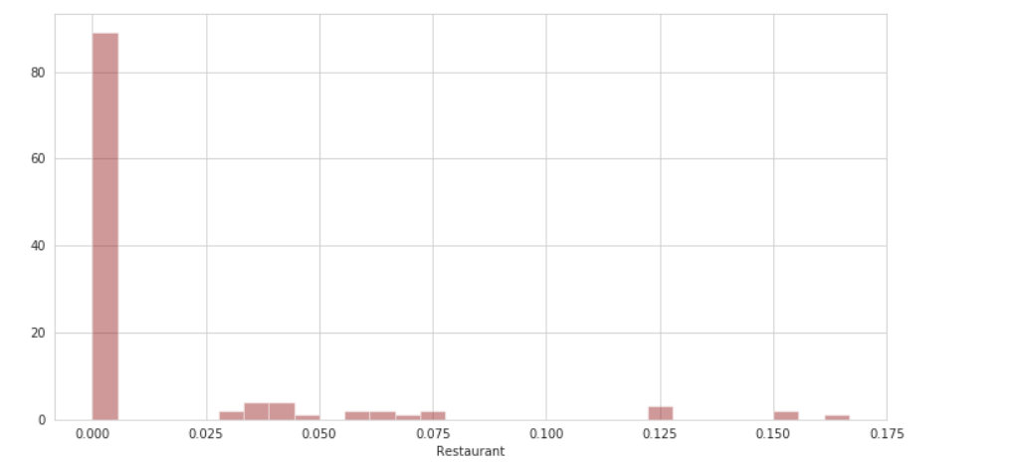

**4.Prediction: -**

* use Kmeans clustering for clustering the restaurant having a similar feature at a different location, after that, I plot the to show the different restaurants at a different location then I suggest on the behalf of the plot which place is better for an opening restaurant.

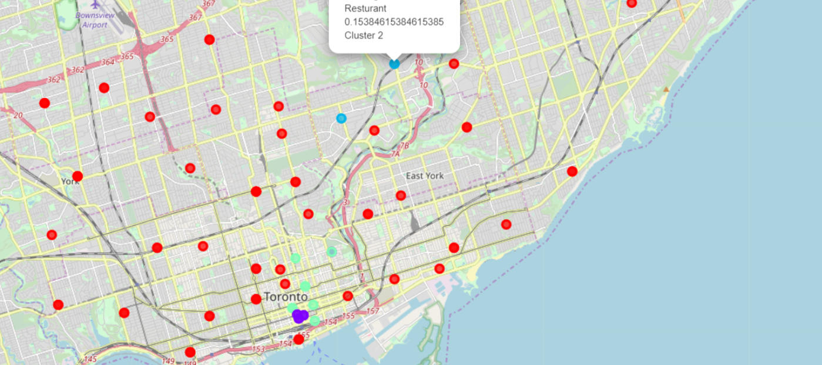

**5. Result**

I successfully cluster the similar type of restaurant at different locations in Toronto according to their feature

**6. Conclusions**

I conclude that the best place for a restaurant in nearby St. Andrew, King, and many other places. I also study a different type of restaurant and analyse them